JDBC Practical

Name: Nur Aina Farisha binti Muhmad Jaffar

Matric: 196488

1. Database db1 is created in MYSQL Workbench. All information in the database are shown below:

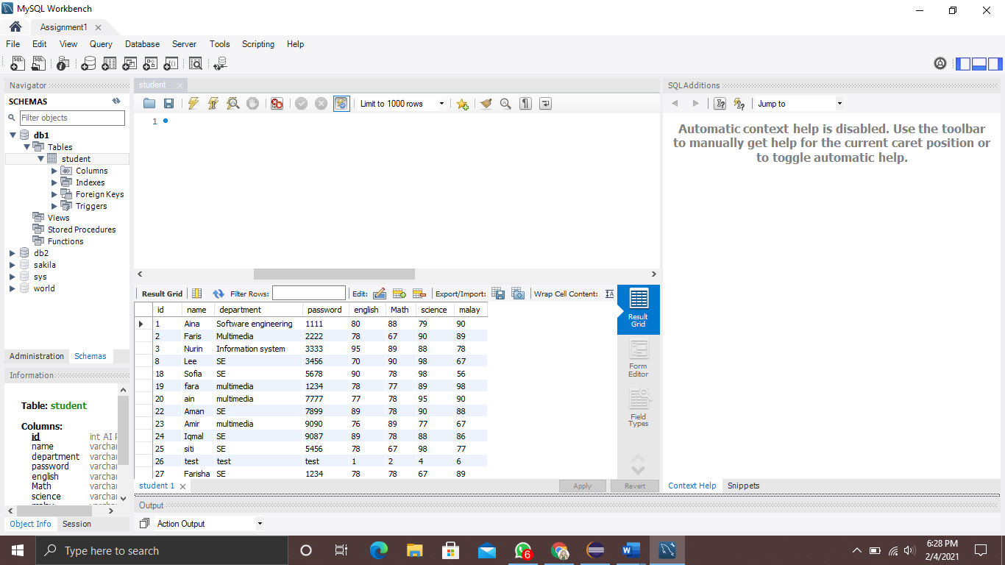

1. Output for student.java. Data is retrieved from db1 in MYSQL.

